**THE PATCO STRIKE DEBACLE**

**WHO WAS RESPONSIBLE?**

**By Judy Ancel, labor educator,** [**ancelj@umkc.edu**](mailto:ancelj@umkc.edu)

***Introduction:***

Many union members and labor historians view the failed PATCO strike of 1981 as a major turning point for workers in U.S. history, which led to four decades of union busting in both the private and public sectors. The defeat of PATCO ended a wave of public sector strikes that began in the early 1960s which raised wages of public employees as well as union density as high as 36%. While employer resistance to strikes was already on the rise in 1980, President Ronald Reagan’s defeat of the Professional Air Traffic Controllers organization and its demise sent a clear message to employers that it was open season on unions and that the power of organized labor which had essentially created a large middle class in America for the first time was broken. Indeed PATCO showed labor to be a “paper tiger, and employers quickly took advantage.” The PATCO debacle and the assault on unions disabled effective resistance to the implementation of “Reaganomics” otherwise known as neoliberalism and the ensuing rise of inequality and destruction of the middle class, an assault that continues today.

Of course, some historians believe that the assault on labor was already underway as a result of the ending of the postwar boom, a profit crisis, and an initiative from corporate elites convinced that labor was too powerful and that it was no longer necessary to pacify American workers with decent wages and benefits and tolerance of unions. This initiative dates back to at least the Powell Memo in 1971 and the formation of elite policy groups like the Business Roundtable.[1]

Nonetheless, whether PATCO was a turning point or a beacon forward for union busting, many workers, union activists and leaders wish the players had acted differently. In this historical roleplay, we will assess the relative culpability of the main players. We will do that by dividing into three groups:

1. PATCO and its members
2. President Reagan, the Federal Aviation Administration (FAA) and its leader, Drew Lewis
3. The AFL-CIO and other unions, especially the Airline Pilots Association (ALPA) and the International Association of Machinists (IAM).

Each group will receive an indictment and must defend itself against the charges.

**INDICTMENTS**

1. **Indictment against the Professional Air Traffic Controllers Organization (PATCO) for (1) illegally striking while failing to first win the support of other unions and the AFL-CIO, for (2) the arrogance to think PATCO members were irreplaceable, and for (3) irresponsibly giving a signal to corporations and government that unions were vulnerable to all-out assault, thus causing great harm to workers and the labor movement, which has lasted until the present day.**
2. **Indictment against President Reagan, Drew Lewis and the Federal Aviation Administration (FAA) for union busting, firing 11,340 hardworking controllers and banning them from future federal employment rather than negotiating with them over their very legitimate grievances, and for setting off a rash of union busting lasting for years, exacerbated by your administration’s gutting of labor law enforcement and deregulation of workplace safety and a number of industries.**
3. **Indictment of the AFL-CIO, its President Lane Kirkland, the International Association of Machinists (IAM), and the Airline Pilots Association (ALPA) as well as other unions for failing to come to the aid of striking PATCO workers in their hour of need, for failing to shut down the airline industry by engaging in sympathy strikes, for hypocrisy of stating support while secretly assuring government that you will not engage in meaningful solidarity, and finally, for failing to insist that the government reinstate fired PATCO strikers.**

Each group must respond to the indictment against it in an open hearing by arguing for their innocence and, if they wish, pointing the finger at some other group. Then we will take questions and challenges from the prosecutor (the teacher), the other defendants, and the jury. Your arguments should aim to convince the jury of your innocence.

We will have a jury of 4-5 who will listen to the arguments, ask questions and decide on the guilt or innocence of each of the accused.

After an introduction to the strike and a film, each group will have 45 minutes to prepare its defense against the charges and assess the responsibility of the other players. Background material is below and in a packet of evidence your group will receive.

Each side will have 10 minutes to present its defense during which the other groups should take notes of weaknesses in the defense. This will be followed by 10 minutes of questions from judges, the teacher and other participants. After all this, the judges will render their decision.

There will be a jury of three drawn from the class. They will decide on a verdict.

After the verdict we will have a discussion on the following questions:

1. What lessons should your union take away from this exercise?
2. Reagan ran on an anti-union platform, and Republicans and the corporations that backed them were already planning to assault labor, cut wages and benefits, and off-shore many jobs. How could the American labor movement have avoided this debacle?

**Video** – Before we break into groups we will watch 15:42 minutes of The Strike that Broke Unions - Reagan vs. PATCO // <https://www.facebook.com/watch/?v=1210034139397144>

Watch the rest after this role play if there is time. The film is a total of 24:15 minutes.

**When you get in your groups do the following:**

1. Read through the Background below.
2. Make sure you understand the indictment against you
3. Deal out the clue cards and have each participant select the ones relevant to your indictment which could either help or hurt your case. Share those.
4. Discuss your defense arguments
5. Decide how you will present your defense.

**Background to the strike and context:**

1. 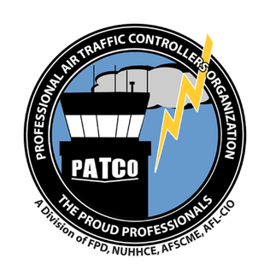**PATCO** The Professional Air Traffic Controllers Organization was formed in 1968. Fundamental issues of the controllers from the start were stress, understaffing, long hours, but the FAA ignored its own regulations on these things. Many controllers were Vietnam veterans. Many were former pilots. Early leaders were Jack Maher and Mike Rock. They built the union with the assistance of celebrity lawyer F. Lee Bailey. They were followed by John Leyden who was replaced just before the strike by Robert Poli because Leyden had lost the confidence of the more militant members.

**The Federal Labor Relations Act (FLRA)** grew out of protests over years by federal workers. Federal employees first obtained the right to engage in collective bargaining through labor organizations of their choice in 1962 when President Kennedy issued Executive Order 10988, which also authorized the use of limited advisory arbitration of grievances.  In 1969, President Nixon expanded those rights through Executive Order 11491, which established the Federal Labor Relations Council to oversee the order, laid out specific unfair labor practices, and authorized the use of binding arbitration of certain disputes.  It also established the Federal Service Impasses Panel. Then, Congress passed and President Jimmy Carter signed Title VII, the Federal Service Labor-Management Relations Statute, as part of the Civil Service Reform Act on October 13, 1978, effective January 11, 1979.

**No Federal Right to Strike** 1955 law punishable by one year in prison. 5 U.S. Code § 7311 - Loyalty and striking: “An individual may not accept or hold a position in the Government of the United States or the government of the District of Columbia if he participates in a strike, or asserts the right to strike, against the Government of the United States or the government of the District of Columbia; or is a member of an organization of employees of the Government of the United States or of individuals employed by the government of the District of Columbia that he knows asserts the right to strike against the Government of the United States or the government of the District of Columbia. ([Pub. L. 89–554](https://www.law.cornell.edu/rio/citation/Pub._L._89-554), Sept. 6, 1966, [80 Stat. 524](https://www.law.cornell.edu/rio/citation/80_Stat._524).)

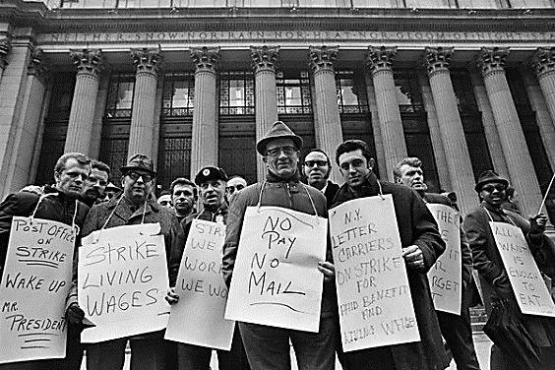Despite the law, in 1970 **postal workers went on strike.** It began in New York City and spread across the nation. It was the largest wildcat strike in history with 210,000 workers on strike for 8 days. The cause was very low wages and an insulting wage offer from Congress which had at the same time given itself a hefty raise. President Richard Nixon ordered workers back to work. The strike spread. He then ordered the National Guard to sort and deliver mail. They botched the job. Finally, he negotiated, and the strike ended peacefully. As a result, Congress passed the Postal Reorganization Act which placed postal workers under the NLRB where they had the ability to negotiate wages. **PATCO workers wanted the same and believed that if postal workers could win gains in a strike, they could too.**

**The economy and the state of labor:** According to Joseph A. McCartin, author of *Collision Course: Ronald Reagan, The Air Traffic Controllers and the Strike that Changed America,*

there was a big difference in worker power between 1970 and 1981. He said,

“As the ‘Reagan revolution’ began refashioning the role of government in American life in 1981, cutting back regulations and spending on social programs, American workers were entering a period of enormous vulnerability. Already the economy was sliding into a recession that would push the unemployment rate up to over 10 percent in 1982, its highest level since before World War II. Income growth had stagnated for most workers; indeed, inflation-adjusted hourly pay had begun to decline in the formerly vibrant manufacturing sector.

**Grievances:** PATCO members complained of high levels of stress caused by the nature of the job of literally being responsible for the lives of hundreds of people every day. Equipment was out-of-date. Wages were too low to justify the stress, which took a real toll on their health. The stress was compounded by unending forced overtime. Controllers suffered from hypertension and other stress-related ailments at extraordinary rates. They were often forced to work up to 20 hours of overtime a week. Nearly 90 percent were leaving before retirement, and about 40 percent of those qualified to collect disability payments. Controllers wanted to safely retire from their jobs before they became burnt out from stress-related disabilities. These frustrations were compounded by real resentments against dictatorial FAA managers who rekindled feelings held against officers by Vietnam vets.

“Moreover, the labor movement, once the bulwark of the liberal order, seemed unable to resist these political and economic trends. Unions had been severely weakened by the economic developments of the 1970s as container ships began disgorging imports in bulk on American waterfronts, oil prices skyrocketed, ‘stagflation’ [simultaneous inflation and stagnation] appeared, factories closed in waves, and employers began fighting unions with a level of determination unseen since the New Deal. As the share of workers organized in unions slipped to under 22 percent in 1981, down from its high point of 35% after World War II, the labor movement was losing clout.”

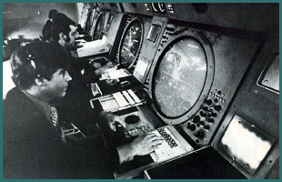

ARTSIII system, 1975

**Militant tactics paid off.** After its founding, PATCO conducted 39 militant work-to-rule campaigns, slowdowns, sick outs and other tactics to get the FAA’s attention.These job actions were popular with the membership and showed a lot of solidarity. They \let off steam and were the only available tactic to win some relief. Many were effective in winning gains. For instance, in 1968 President Lyndon Johnson signed a bill giving PATCO dues checkoff and exempting them from overtime caps. President Nixon rehired controllers who had been fired during a nine-month sickout and gave controllers over age 50 a full pension after 20 years of service and the same for anyone of any age after 25 years. PATCO won recognition in 1972 with 82% for representation by the union.

*“Between 1972 and 77, PATCO emerged as the most militant, most densely organized in any bargaining unit of the nation’s largest employer, the US Government.”* Joseph McCartin

**In 1976, PATCO endorsed Jimmy Carter** hoping that he would get them the right to negotiate over wages, but in the end they felt that Carter did far too little. Many members were upset that Carter’s reforms to federal labor law did not include the right to strike. The right to negotiate wages was defeated as well as alarm over rising budgets and rampant inflation.

**In 1980 PATCO endorsed Ronald Reagan.** PATCO presented Reagan with a list of points they wanted him to agree to in exchange for their endorsement: the right to negotiate pay, the right to strike in some circumstances, better working conditions, shorter hours. Reagan agreed and told them: “I pledge to you that my administration will work very closely with you to bring about a spirit of cooperation between the President and the air traffic controllers.” During the campaign, Reagan acknowledged that equipment outages and undue stress plagued the system. He said, “...too few people working unreasonable hours with obsolete equipment has placed the nation’s air travelers in unwarranted danger.”

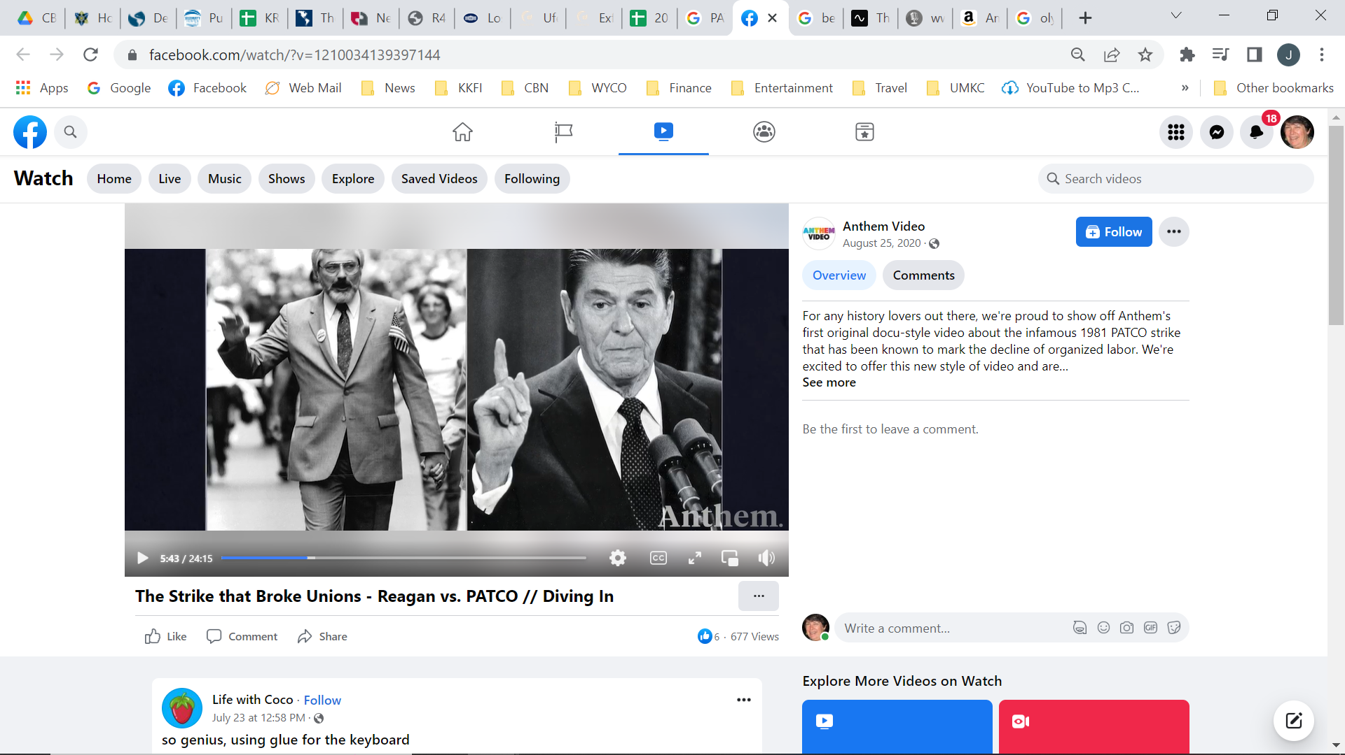

*“In this present crisis, government is not the solution for our problem. Government is the problem”* Ronald Reagan

**President Reagan appointed Drew Lewis** to head the FAA and the PATCO negotiations. On June 22nd Lewis and PATCO’s Robert Poli reached a tentative agreement that included a 5% salary increase and 36-hour work week. The rank and file overwhelmingly rejected this deal. It was clear the leadership did not represent the members who wanted much more. The leaders had no choice but to show unity with a strike.

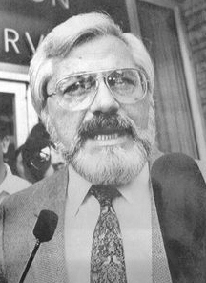

PATCO President since 1980 Robert Poli

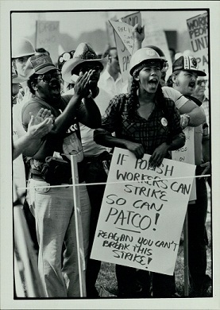**The strike began on August 3rd.** PATCO set up pickets and shut down the system across the U.S.

**That same day Reagan made a public statement:** *“This morning at 7AM the union representing those who man America’s air traffic control facilities called a strike. This was the culmination of seven months of negotiations between the Federal Aviation Administration and the union. At one point during these negotiations, agreement was reached and signed by both sides granting a forty million dollar increase in salaries and benefits. This is twice what other government employees can expect. It was granted in recognition of the difficulties inherent in the work these people perform. Now however, the union demands are seventeen times what had been agreed to, seventeen times! Six hundred and eighty-one million dollars. This would impose a tax burden on their fellow citizens which is unacceptable.*

Atty Gen’l Wm. French Smith, Reagan, Transportation Sec’y Drew Lewis

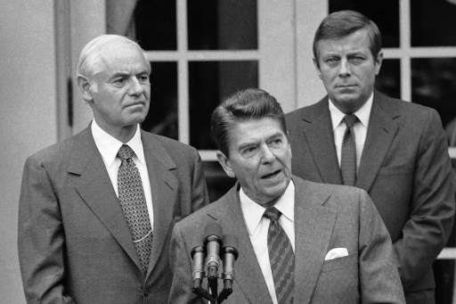

*I would like to thank the supervisors and controllers who are on the job today helping to get the nation’s air system operating safely. In the New York are for example, four supervisors were scheduled to report for work, and seventeen additionally volunteered. At National Airport a traffic controller told a news person he had resigned from the union and reported to work because, ‘How can I ask my kids to obey the law if I don’t.’ This is a great tribute to America.*

*Let me make one thing plain: I respect the right of workers in the private sector to strike. Indeed as president of my own union I led the first strike ever called by that union. I guess I’m the first person ever to have held this office who is a lifetime member of an AFL-CIO union, but we cannot compare labor relations in the private sector with government. Government cannot close down the assembly line. It has to provide without interruption the protective services which are governments reason for being. It was in recognition of this that the Congress passed a law forbidding strikes by government employees against the public safety. Let me read the solemn oath taken by each of these employees, the sworn affidavit when they accepted their jobs. ‘I am not participating in any strike against the government of the United States or any agency thereof and I will not so participate while an employee of the government of the United States or any agency thereof.’ It is for this reason that I must tell those who fail to report for work this morning, ‘They are in violation of the law, and if they don’t report for work within 48 hours they have forfeited their jobs and will be terminated.’”* <https://millercenter.org/reagan-vs-air-traffic-controllers>

Sources:

Joseph A. McCartin, Collision Course ; Ronald Reagan, the Air Traffic Controllers, and the Strike that Changed America 2011

Erik Loomis, *A History of America in Ten Strikes* 2018

Steve Babson, *The Unfinished Struggle: Turning Points in American Labor, 1877-Present* 1999

Glenn Houlihan, *The Legacy of the Crushed 1981 PATCO Strike,* Jacobin, 8/3/2021

NATCA, *A History of Air Traffic Control* <https://www.natca.org/wp-content/uploads/2019/12/NATCA_ATC_History.pdf>

FAA, Air Traffic Control History <https://www.faa.gov/about/history/photo_album/air_traffic_control#:~:text=Early%20Airway%20Traffic%20Control,facility%20during%20the%20following%20year>.

Video: The Strike that Broke Unions - Reagan vs. PATCO // <https://www.facebook.com/watch/?v=1210034139397144>

1. The memo was written by future Supreme Court justice Lewis Powell, a corporate lawyer to the head of the US Chamber of Commerce and is seen by many as a blueprint for the assault on working people. <https://www.greenpeace.org/usa/democracy/the-lewis-powell-memo-a-corporate-blueprint-to-dominate-democracy/>